Gray Program Evaluation System (PES):
- Database on academic market drivers including inquiries, applications, demographics, competition, job openings, job postings, and placement rates.
- Scored potentiality of all IPEDS programs for each individual local market using data on student demand, competitive intensity, and job opportunities.
- Identified Markets for Mercer
  - Atlanta 50-mile radius
  - Macon 200-mile radius
  - State of Georgia
  - Southeast Region (GA, TN, NC, SC, AL, FL, TX East of San Antonio)
  - National (online)
- Major Categories
  - Student Demand
    - student inquiries– size and trends in demand by program; weak current indicator
    - completions – program size and YoY growth; strong lagging indicator
    - Google search – Google searches on top 25 keywords for largest 200 programs; current indicator limited to larger programs.
  - Employment
    - Employment
    - Job Openings (Growth)
    - Wages
    - Postings (Postings per Graduate)
  - Competitive Intensity
    - number, density, type of institutions
    - Average and Median Size of programs
  - Degree Fit
    - degree levels by completions
    - degree levels by employment
    - wages

Academic personnel with PES access
Academic Unit
LIB | Jeffrey Waldrop | Scott Gilles
NUR | Linda Streit
CLA | Anita Gustafson | Jeff Denny
BUS | Julie Petherbridge | Vijaya Subrahmanyam | Jim Hunt
MUS | Doug Hill | Rich Kosowski
COP | Brian Crabtree | Candace Barnett | Jill Augustine
EDU | Kelly Reffitt | Jeff Hall
MED | Marie Dent | Bonnie Dickerson
CHP | Leslie Taylor | Laura Ellison | Lisa Lundquist
CPV | Gail Johnson | Colleen Stapleton
EGR | Stephen Hill | Scott Schultz
THE | Karen Massey | Rob Nash
LAW | Susan Knight | Sarah Gerwig-Moore
Provost | Keith Howard | Susan Malone

Available Reports
Program Rank- A scored ranking of academic programs by CIP. Rankings are summed across four major sub categories.
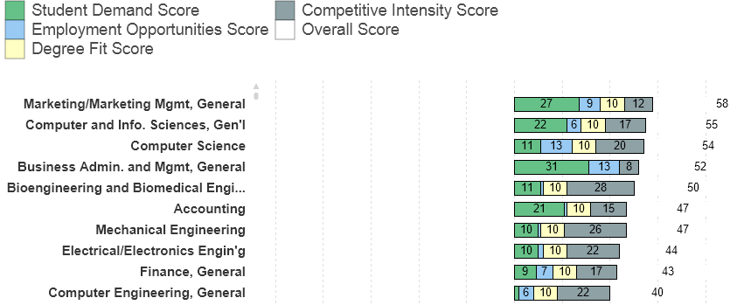

Program Scoreboard- Detailed overview of the scoring metrics from each of the four major categories. The values on these categories are the important data metrics, not the score. The score is a combination of Gray and Mercer set priorities assigned to develop a market ranking system. CIP description is included.
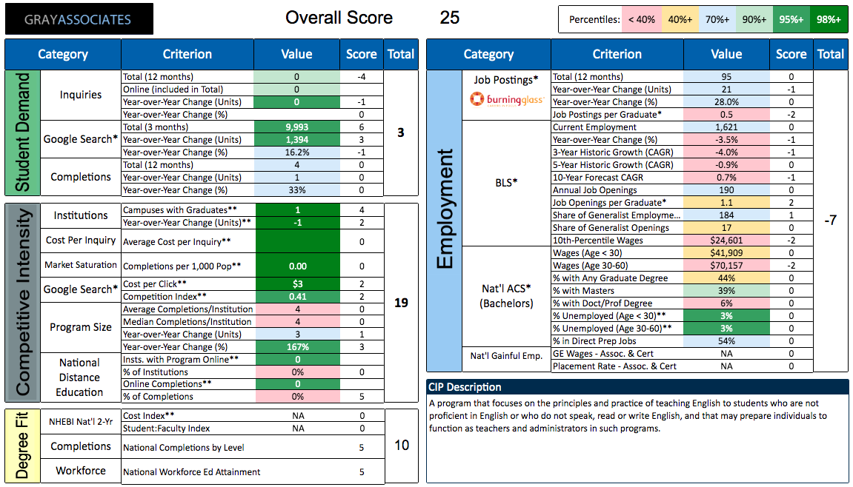

Award Level Breakdown by Source (Inquiries and Completions)- Distribution of inquiries and completions, job postings, and workforce by award level.

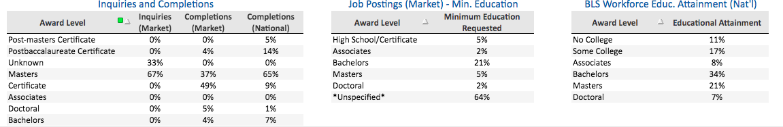

Scaled Market Matrix- Scores by Program and Market- Similar to Program Rank but with cross-comparisons across markets
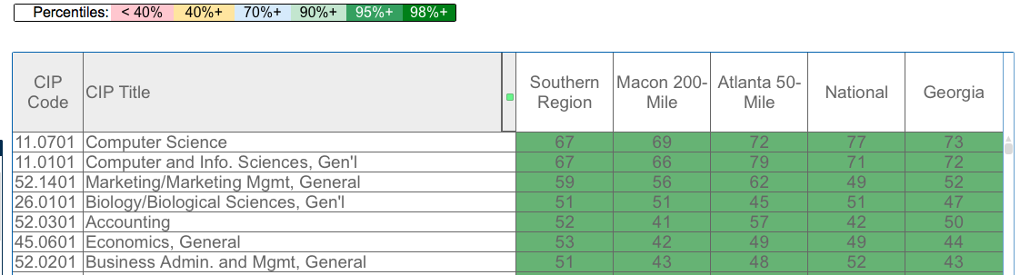

Competitor Table- Identifies competitors with program completions by market and award level. Competitors may be identified CIP, academic unit, or overall market.
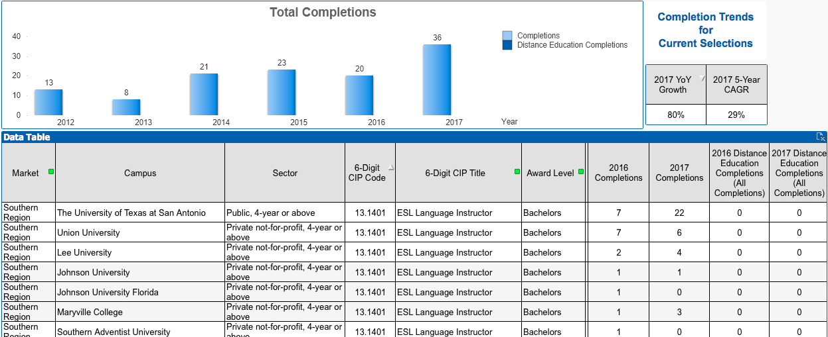

Data Tables- Individual tables of data across metrics may be developed. Data categories include:
Student Demand: Inquiries (Total, Prior Year, YoY unit, YoY %), Google Searches (Total, YoY unit, YoY %), IPEDS Completions (Total, YoY unit, YoY %)
Employment Opportunity: Job Postings (Total, YoY unit, YoY %), BLS Direct Prep Jobs (Current, YoY %, 3 yr growth, 5-year growth, 10-year forecast, future employment, replacement jobs, annual openings, openings per graduate, 10th % wages, 25th % wages, share of generalist jobs, share of generalist openings), National ACS (Bachelors) (Wages <30, Wages 30-60, % Grad Degree, % Masters, % Doc/Prof Deg, % Unemployment <30, % Unemployment 30-60, % Direct Prep), Gainful Employment (Assoc & Cert) (Wages, Placement Rates)
Degree Fit: Inquiries(Market) by award level, Completions(Market) by award level, Job Postings(Market) by award level, BLS Workforce Educational Attainment by award level, Cost Benchmarks (NHEBI National 2-Yr)
Competitive Intensity: IPEDS Institutions (# Campuses, YoY units, # private for-profit, # private non-profit, # public) Market Saturation (Completions per 1000pop), Inquiries (Ave Cost per inquiry), Google Searches (Cost per click, Competition Index), Program Size (Ave Completions per Institution, Median Completions per Institution, YoY unit, YoY %), Online Competition (# Campuses, % of Institutions, Online Completions, % of Completions), IPEDS Online Completions

Workplace Requirements: Provide ranked lists of abilities, activities, knowledges, occupations, skills, tools, and behaviors associated with the CIP. Information in these categories is more comprehensive for direct prep CIPs.

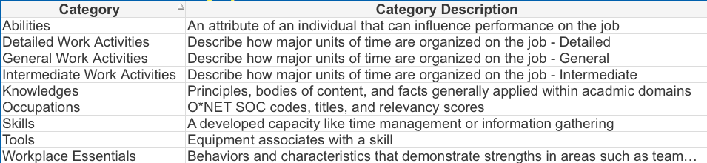

Tables from Gray Associates Program Evaluation System
[Each school/college should have someone who has access to the Gray system and has been trained to create and extract these tables for you.]

The following tables are required unless otherwise noted; you may choose to include additional ones.

IPEDS Institutions with Graduates
IPEDS Institutions: Campuses with Graduates | IPEDS Institutions: Year-over-Year Change (Units) | Number of Private For-Profit Institutions | Number of Private Not-for-Profit Institutions | Number of Public Institutions

Rationale for inclusion: Provides indicator of the concentration and growth of competing programs. Parsing this data by institutional type can be informative to a determination of institutional fit.

2-year Market Median Data on Program Size and YoY % Change and IPEDS Completions YoY%.
Program Size: 2017 Median Completions/ Institution | Program Size: 2016 Median Completions/ Institution | Program Size: Year-over-Year Change (%) | IPEDS Completions: Year-over-Year Change (%) | Inquiries:  Year-over-Year Change (%)

Rationale for inclusion: Median program completions within the Market provides a benchmark that is predictive of student demand within the market and estimation of potential program size. Should be considered in parallel with individualized completions data for market competitors.

Gray Institutional and Online Completions Data (Online programs only)
Online Competition (National): Institutions with Program Online | Online Competition (National): % of Institutions | Online Competition (National): % of Completions | IPEDS Completions: 2017 in Programs Offered Online | IPEDS Completions: 2016 in Programs Offered Online

Rationale for inclusion: Online programs default to a national market. The Institutional and Online Completions Data provides perspective on the level of demand for online version of the program. The IPEDS completions provides illustrates demand within the given market.

Market Inquiries Data (Online programs only)
Inquiries (Market): Undergrad Certificate | Inquiries (Market): Associates Degree | Inquiries (Market): Bachelors Degree | Inquiries (Market): Post-baccalaureate Certificate | Inquiries (Market): Masters Degree | Inquiries (Market): Post-Masters Certificate | Inquiries (Market): Doctoral Degree | Inquiries (Market): Unknown Level

Rationale for inclusion: Online Inquiries are better predictors of the online offerings and are less predictive for than for traditional in-person programs. The Market Inquiries Data provides insight on the desired program level associated with student demand.

Market Competitor Table for the appropriate award level of select (at least 5) competitors. [If online program, choose completions from online programs.]
Campus | Award Level | 2012 Completions | 2013 Completions | 2014 Completions | 2015 Completions | 2016 Completions | 2017 Completions
Rationale for inclusion: IPEDS completions data for competitors identifies top institutional competitors and program size. Competitors may be identified within or across markets.

Job Posting and BLS Jobs Forecast Table.
Market | Job Postings: Job Postings per Graduate | BLS Direct Prep Jobs: Job Openings per Graduate | BLS Direct Prep Jobs: Year-over-Year Change (%) | BLS Direct Prep Jobs: 3-Year Historic Growth (CAGR) | BLS Direct Prep Jobs: 5-Year Historic Growth (CAGR) | BLS Direct Prep Jobs: 10-Year Forecast CAGR

Rationale for inclusion: Job Postings and BLS Jobs Forecast provides a employability impacting post-matriculation value to students
Market | BLS Direct Prep Jobs: 10th-Percentile Wages | BLS Direct Prep Jobs: 25th-Percentile Wages

BLS Direct Prep Salary Table

Rationale for inclusion: Predictive of post matriculation salary expectations post-matriculation.

BLS Workforce Educational Attainment Table
BLS Workforce Educ. Attainment (Natl): No College | BLS Workforce Educ. Attainment (Natl): Some College | BLS Workforce Educ. Attainment (Natl): Associates | BLS Workforce Educ. Attainment (Natl): Bachelors | BLS Workforce Educ. Attainment (Natl): Masters | BLS Workforce Educ. Attainment (Natl): Doctoral | BLS Workforce Educ. Attainment (Natl): Graduate

Rationale for inclusion: Descriptive of level of education attainment needed for employability within the field.

Inquiry and Completions Awards Level Table
Award Level | Inquiries  (Market) | Completions  (Market) | Completions  (National)
Certificate | % | % | %
Associates | % | % | %
Bachelors | % | % | %
Postbaccalaureate Certificate | % | % | %
Masters | % | % | %
Post-masters Certificate | % | % | %
Doctoral | % | % | %

Rationale for inclusion: Roll-up of data identifying appropriateness of matriculation level of offering.
(Optional*) Occupations Table from Gray Workplace Requirements.
Skills Engine Score | Skills Engine Result
*Utility of Skills Engine Tables varies greatly by CIP code.

Rationale for inclusion: Occupational skills needed should inform curriculum and learning outcomes. Impact of data from Workplace Requirements is stronger for direct employability CIP than for generalist areas.

